IAM
- Create one IAM user and assign ec2,s3 full access role.
IAM user create user

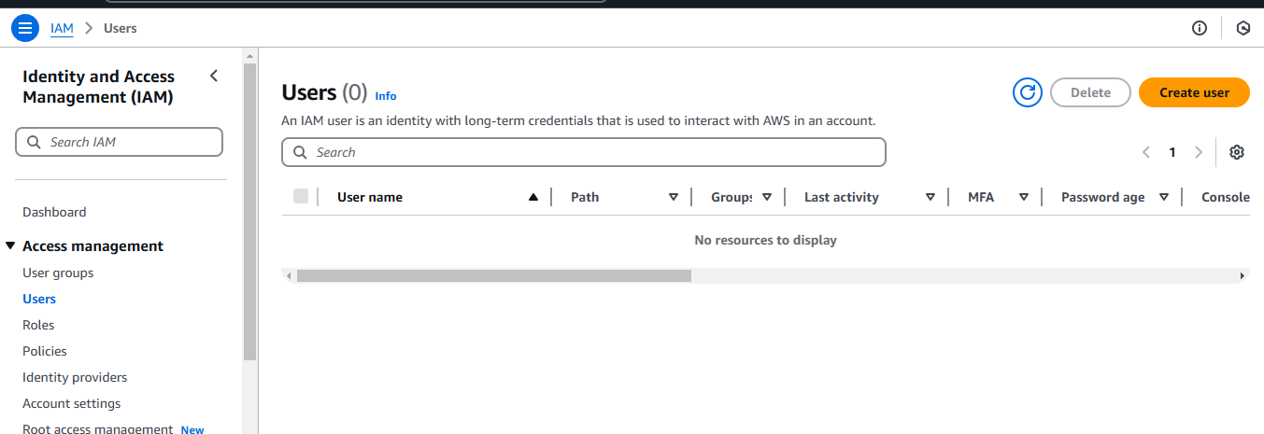
Give add user to group or attached policy

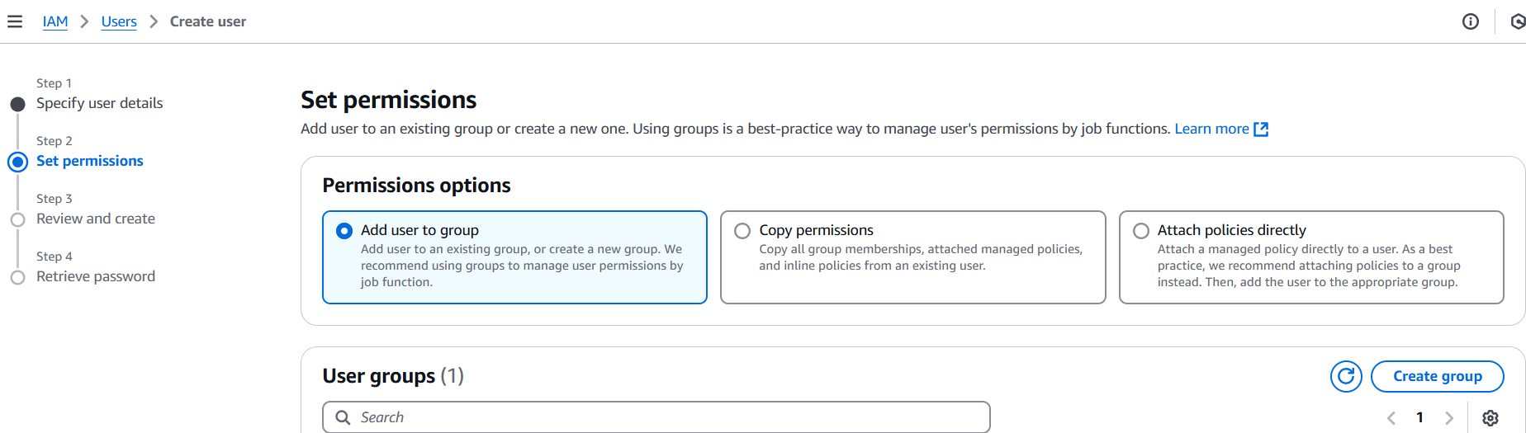
Go to policy and give full permissions to user
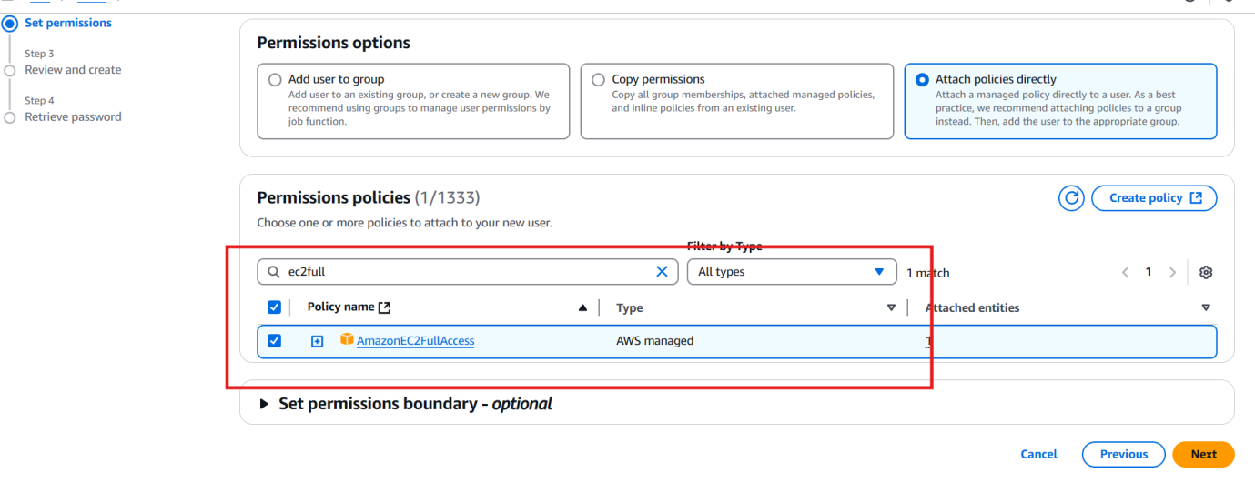
Given full permission to EC2 and S3
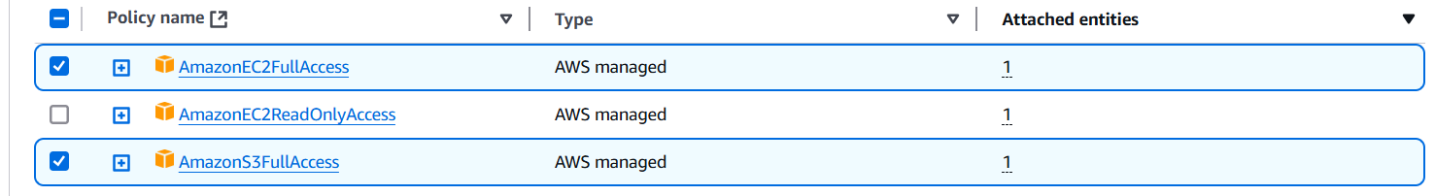
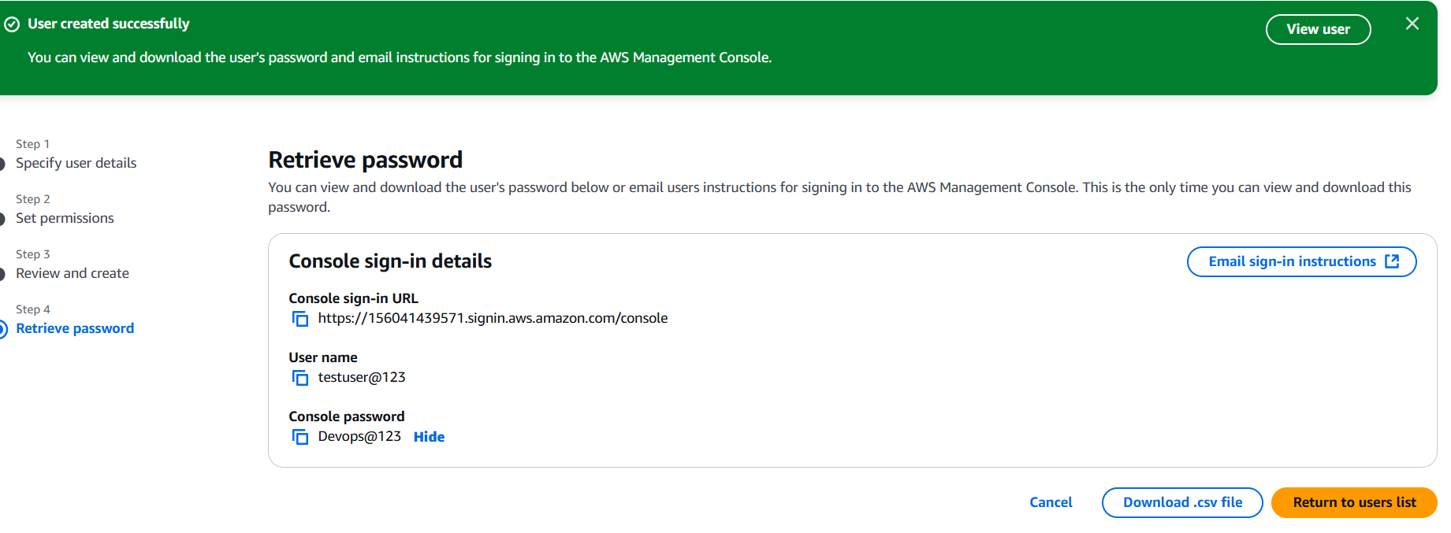
- Create one Group in IAM and Assign Read access for ec2
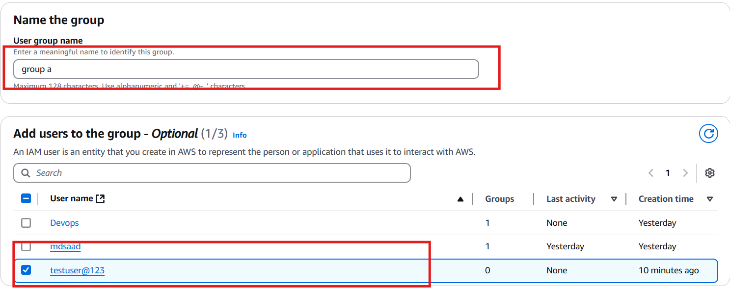
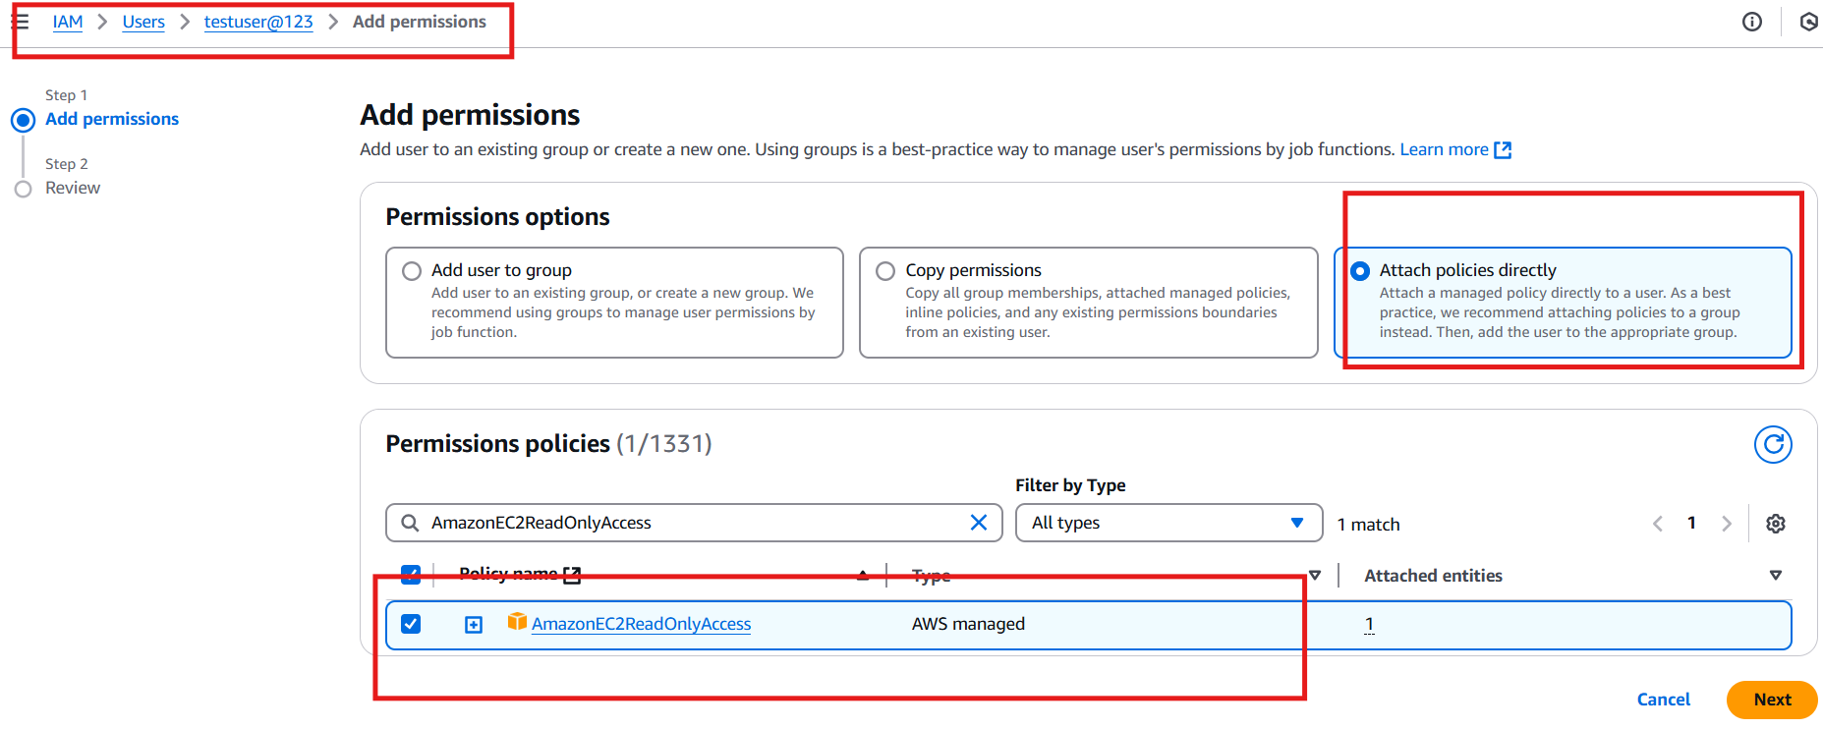
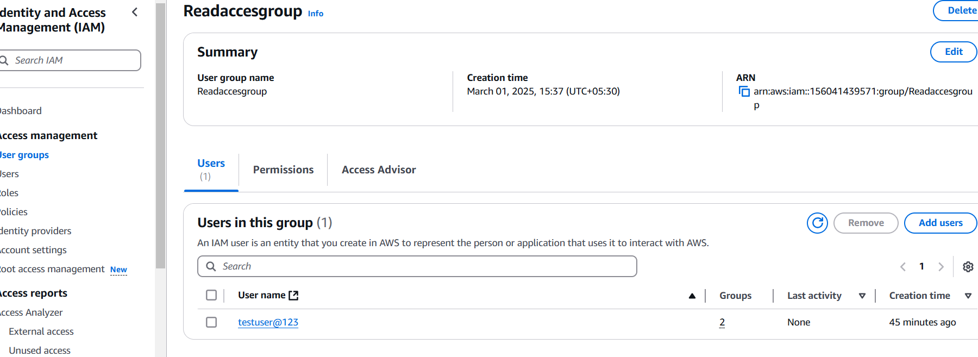
- Create a new user with name DevopsOperation and add to the group created in task2.

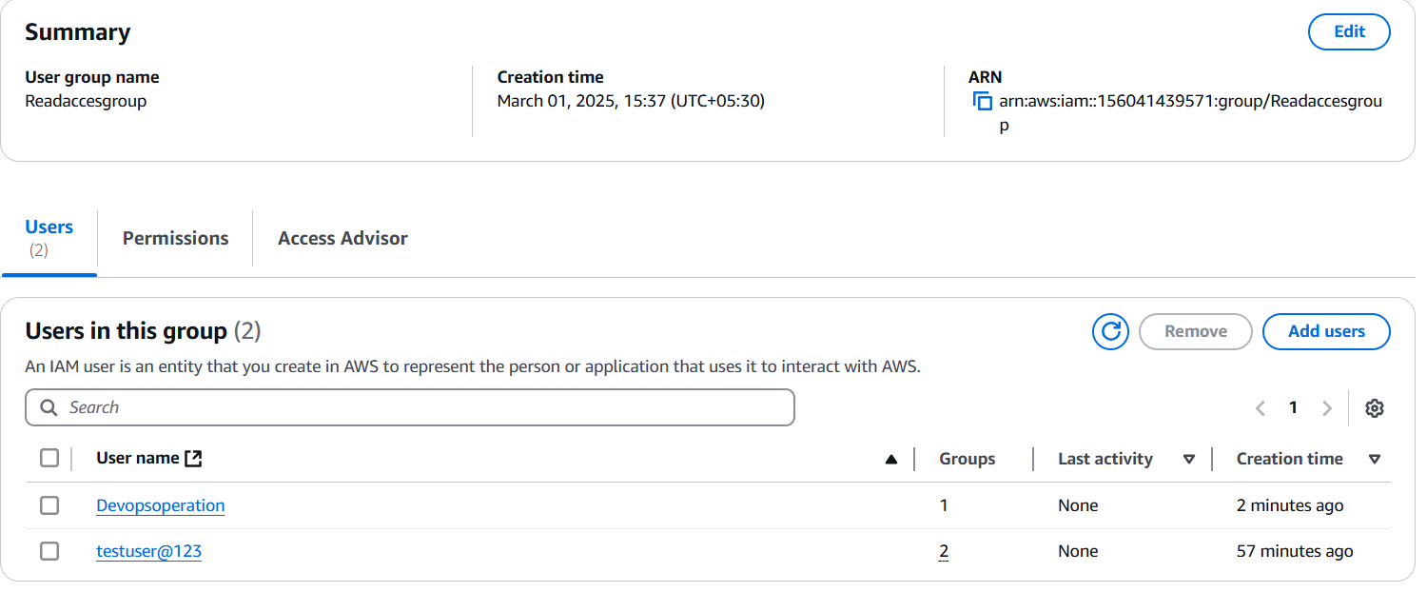
- Write a bash script to create a IAM user with VPC full access.
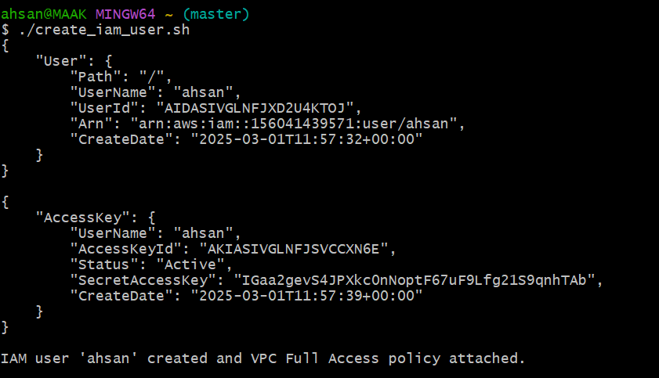
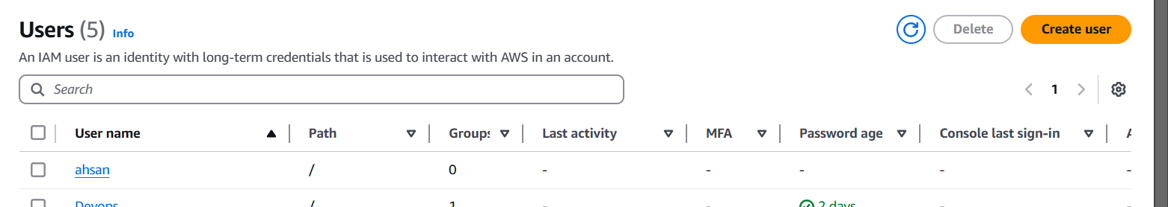

5 Create a IAM policy to access ec2 for a specific user in specific regions only.)
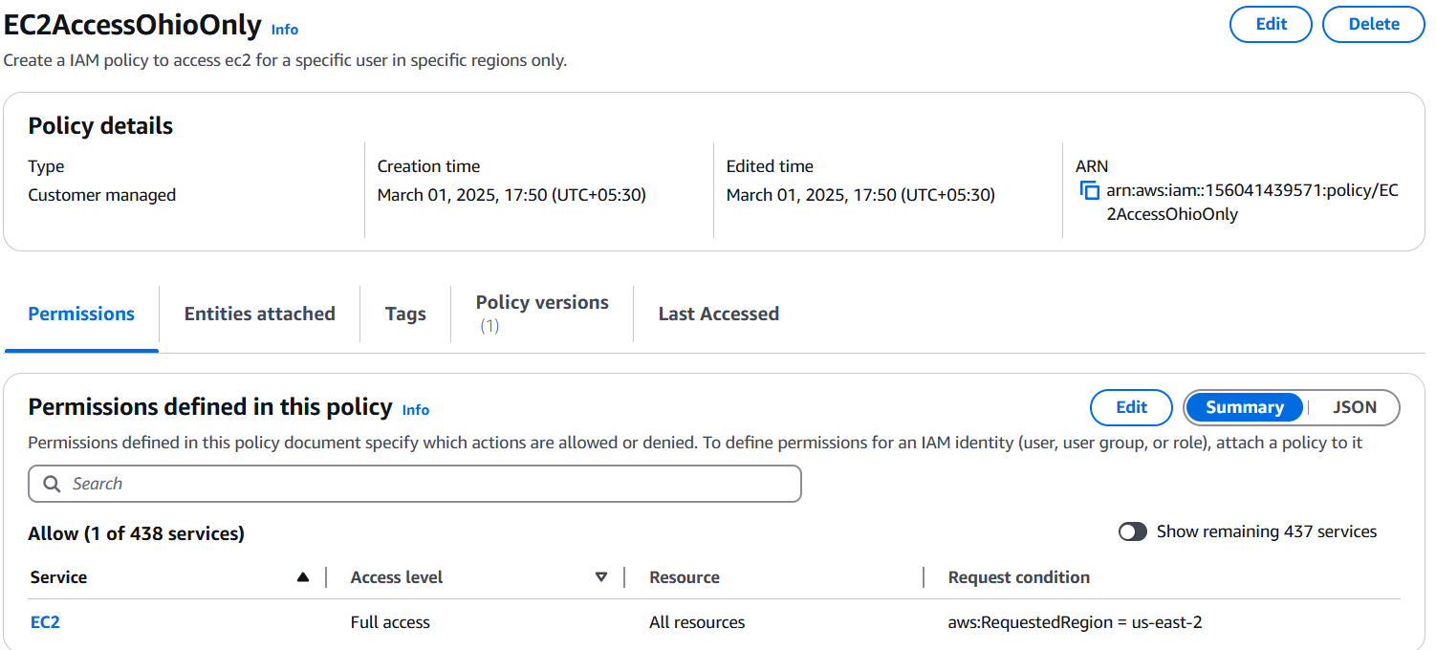

6) We have two accounts Account A and Account B, Account A user should access s3 bucket in Account B.
6

